## **Integration of Jenkins with** **GitHub**

1. Login to Jenkins.

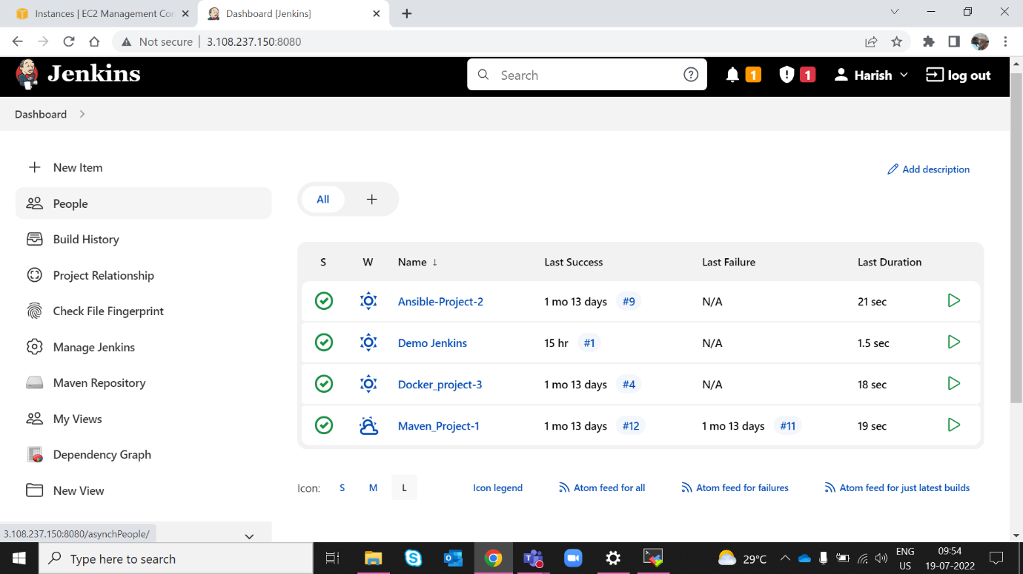

1. Create new item

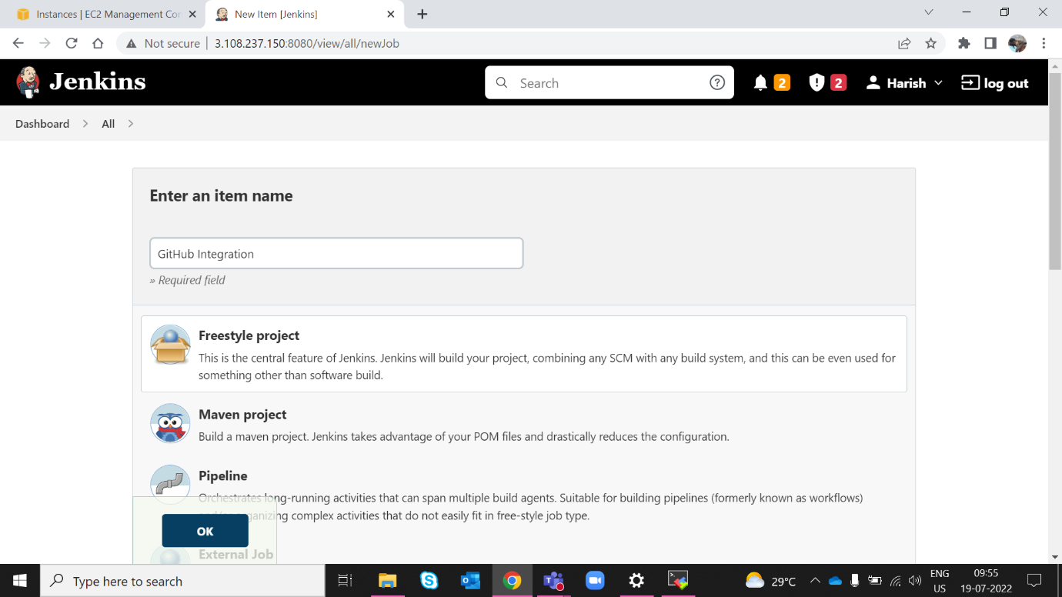

1. Select the source code management Tab and select git and add your GitHub repo. And click on save and apply.

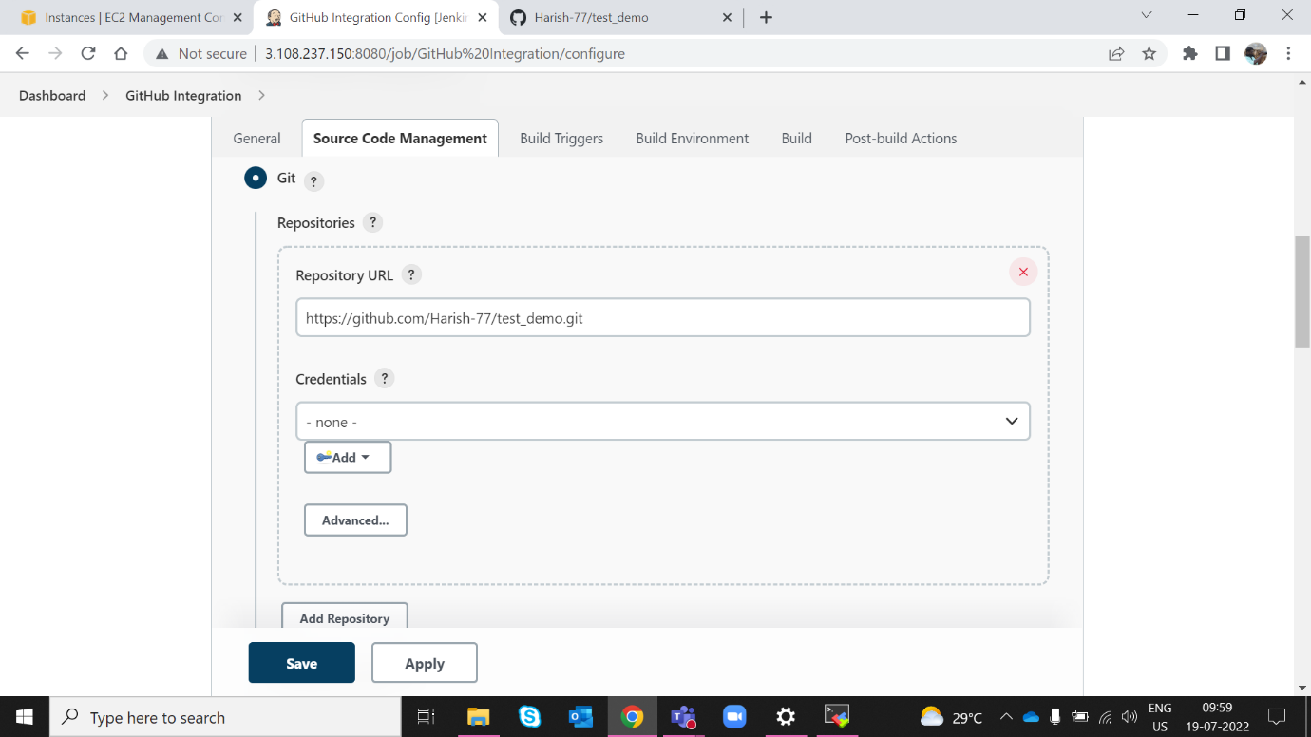

1. Click on Build now Option.

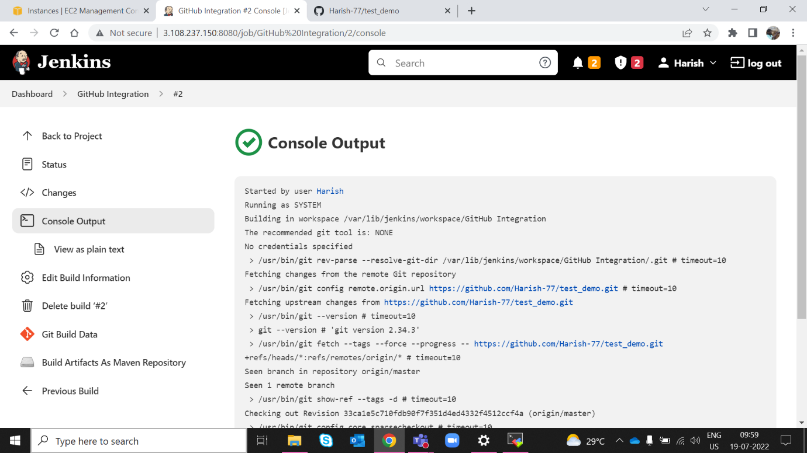

## **Integration of Jenkins with SSH key**

Step1: Install publish over SSH Plugin

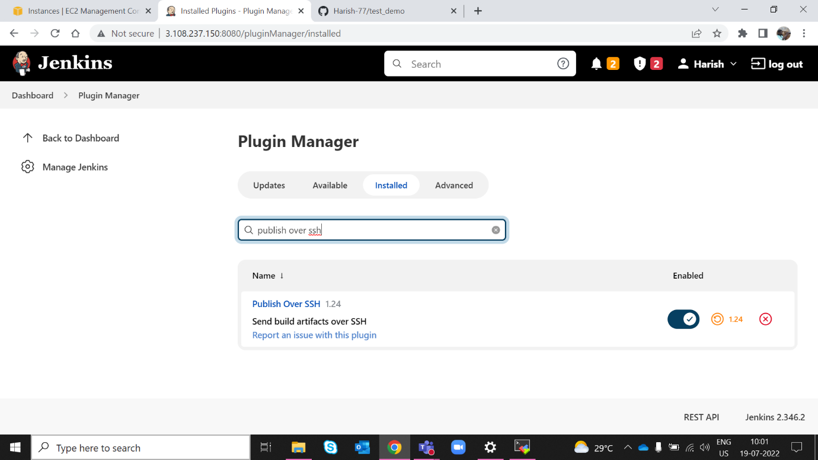

1. Step 2: We can generate a key with Putty key generator, or by running the following command in git bash: $ ssh-keygen -t rsa -b 4096 -C your_email@example.com

Step3: Go to manage Jenkins -> configure system ->publish over ssh tab->key-> paste the private key.

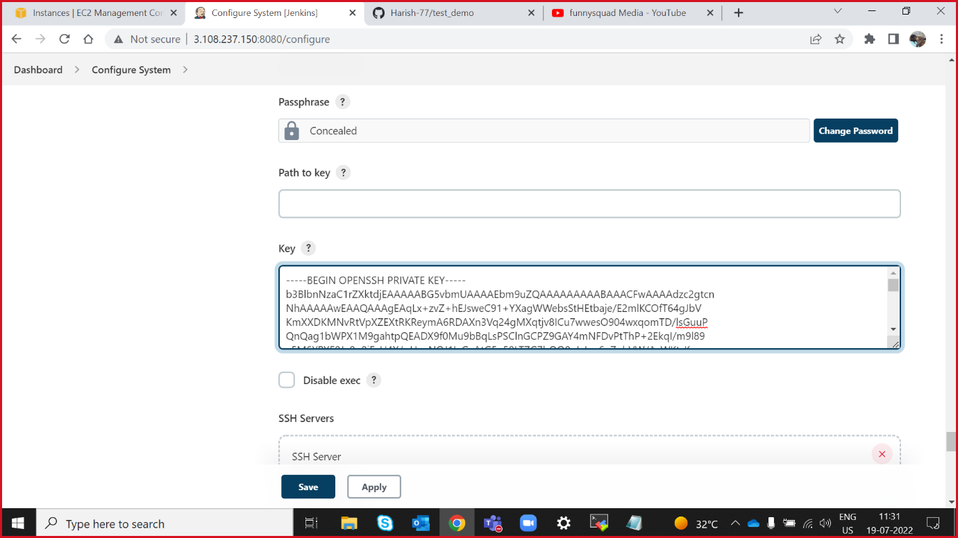

## **Integration of Jenkins with GitHub hooks**

**Step 1:** go to your GitHub repository and click on **‘Settings’.**

**Step 2: Click on Webhooks and then click on ‘Add webhook’.**

**Step 3:** In the **‘Payload URL’** field, paste your Jenkins environment URL. At the end of this URL add /github-webhook/. In the**‘Content type’** select: ‘application/json’ and leave the **‘Secret’**field empty.

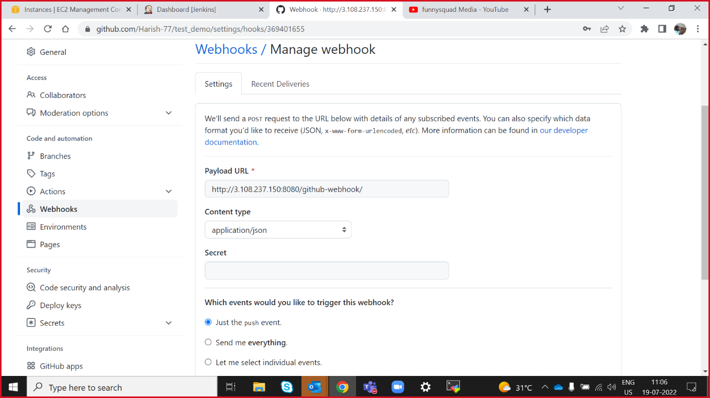

### Configuring Jenkins

**Step 4:** In Jenkins, click on**‘New Item’** to create a new project.

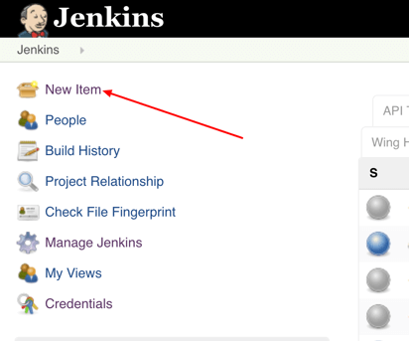

**Step 5:**Give your project a name, then choose ‘Freestyle project’ and finally, click on ‘OK’.

**Step 6:** Click on the **‘Source Code Management** tab.

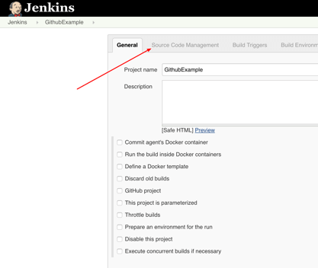

**Step 7:** Click on Git and paste your GitHub repository URL in the**‘Repository URL’** field.

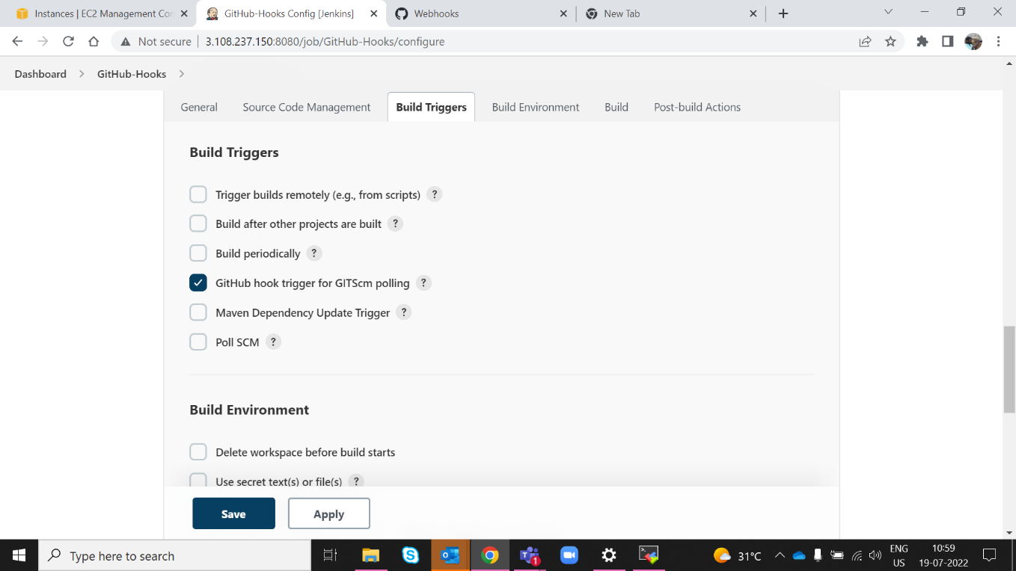

**Step 8:** Click on the**‘Build Triggers’**tab and then on the ‘GitHub hook trigger for GITScm polling’. Or choose the trigger of your choice.

